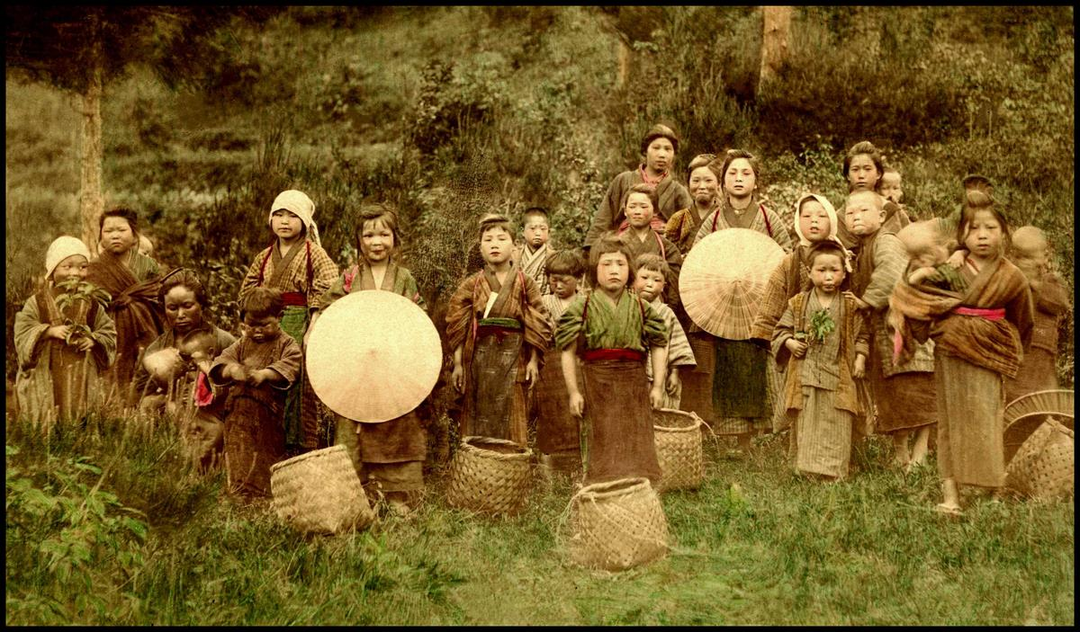
Teachers’ guide
200 years that changed the world
A lecture with Gapminder World about global development
from the industrial revolution until today.

Produced by
Mattias Lindgren, the Gapminder Foundation. Version: 2010-08-18

This guide is available at: www.gapminder.org/downloads/200-years

More teaching materials available at www.gapminder.org/for-teachers/

License
You are free to use and re-distribute this material
for non-commercial purposes under a creative
commons licence. We ask you to credit as the source: www.gapminder.org

More teaching materials available at www.gapminder.org/for-teachers/

Photo: 19th century Japanese child labourers. Credits Okinawa Soba (see last page).
About this lecture
Level: secondary school.
Subjects: history, geography & social studies.
What you need: a computer, a screen and a projector.

Overview
Gapminder World as it looks when you open it
This is a teachers’ guide on how to do a lecture about global development since 1800. A similar lecture by Hans Rosling can be viewed at: www.gapminder.org/videos/200-years-that-changed-the-world/.

You will use the Gapminder World graph available at www.gapminder.org/world. Click play and the graph animates the progress in GDP per capita and life expectancy for all countries from 1800 to today.

Contents of this guide

Lesson outline ................................................................................. page 3
How to use the Gapminder World Graph ................................. page 4
Additional suggestions ................................................................... page 5
“If students ask” – background information ............................. page 15

Key messages of the lecture
- In 1800, income per person was low and life expectancy was very short in all countries.
- Health is better everywhere today, even in the poorest countries.
- Income is much higher in most, but not all, countries today.
- The income and health gaps between countries are larger today.
- Most people today live in “middle income” countries
Outline of the lecture

1. Preparations: Start the computer and projector. Open the graph by clicking on www.gapminder.org/world or by downloading the offline version at www.gapminder.org/desktop/. Click “full screen”. You should have “Life expectancy” on the vertical axis and “Income per person” on the horizontal axis. Pull back the time bar to 1800.
2. Explain the graph: “Each country in the world is a bubble”, “the size of the bubbles represent the population size”, “colour represents regions of the world”, “the vertical axis is the average life span”, “the horizontal axis is income per person”. Point while you explain.

3. Briefly describe the situation in 1800: Point out a few countries. Describe the situation briefly, e.g. that income is low and health is poor in all countries.
4. Click play: Display the progress from 1800 until today and comment on what you see. Do step 3-4 relatively quickly, to show the animation once.
5. Discuss the income gaps today: Explain how you can categorise countries into low (<$2000), middle ($2000-$20,000) and high (>$20,000) income countries.
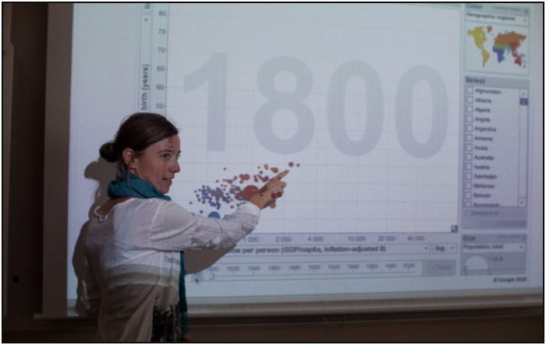6. Discuss the link between income and health today: Why are money and health related? Can you see exceptions? Why do you think some countries are unhealthier than others with the same income?
A teacher displaying the Gapminder World graph
7. Go back to 1800 and discuss: Why was health poor everywhere, even in the richest countries? Why was the UK richest in 1800?
8. Replay 1800-today more slowly. You can stop the graph at some key years, e.g. 1950. After 1950, important changes happened that you can discuss: health improved everywhere (medical advances); the catch-up of “the east”, the boom of the oil countries, the setback to health caused by HIV in the 1980s.
9. Summarize the key messages of the lecture: Health and economy bad everywhere in 1800; health better everywhere today; income higher in most, but not all, countries today; gaps are larger today; most live in middle income countries today.

Watch the graph change over time by using these buttons
Change the speed of the graph here
Click here to select indicators for the x axis. You can also choose to display time on this axis.
Change the size of the bubbles here.
The size of the bubbles normally represents the population of the country. Click here to make the size proportional to another indicator.
Remove all countries other than those selected here.
Deselect all countries here
Click here if you use the graph in a lecture. The graph will cover the whole screen.
Adapted from an original idea by wwww.juicygeography.co.uk

Click here to get a short link to the specific graph you have created
Select Chart or Map view
Click here for a short tutorial video.
Select individual countries here by clicking the boxes. You can also click on the bubbles.
Click Trails to track a selected country while an animation plays
The countries on the graph are colour coded by continent. Here you can choose to colour code them by other indicators.

Both the x and y axis scales can be linear or logarithmic. Choosing log scale may make it easier to see the trends on the graph.
Hover your mouse over the bubble to reveal the names of the countries
Click here to select indicators for the y axis
Click here to open a tool that help you zoom in or out. Click 100% to see the whole graph again
If you want information about the sources you can click on the small print next to the axis.
Additional suggestions

The next section repeats the steps in the lesson outline. For each step we have ideas for things to say and discuss, as well as some background information.
There are far too many suggestions to fit into one class, so we suggest that you only select some of them.

- Preparations
Prepare the projector and the classroom computer. Enter the Gapminder World graph online with the computer through: www.gapminder.org/world or download the offline version at www.gapminder.org/desktop/
Once the graph is open drag the time bar at the bottom of the graph back to 1800. No other adjustments are needed. You should have Life expectancy on the vertical axis, Income per person on the horizontal axis, population as size, and regions as colour.
Click “full screen”. You will find the button on top of the graph. By now you should see the following:
Recalculate the income at the cut-off levels. One suggested clarification later on is to express the income in your own currency. Divide the dollar values by the present exchange rate for your currency if you plan to express income in your own currency.

2. Explain the graph
It is important that you explain the graph very carefully, step by step, even if your audience has seen a similar graph before. Point to the graph directly as you explain.
Explain the bubbles. Say that “Each country in the world is a bubble”, “the size of the bubbles represent the population size”, “colour represents regions of the world”. Point while you explain.
Explain the vertical axis. Explain that the vertical axis shows the average life span in each country. It goes from 25 years to 85 years. High up = long lives = good health. It is often clearer and more effective if you point things out on the graph. You could point out one healthy and one unhealthy country just to illustrate.
Explain the horizontal axis. Explain that the horizontal axis shows what the average income per person is (it is actually the GDP per capita). It is expressed in dollars per person per year. To the right = rich, to the left = poor. An average below $400 means that the average income is very close to the poverty line of $1.25 per day.
Explain that this is the situation in 1800. You can point out that the year in the middle of the graph tells you the year on display.
Give some quick examples. When you hover the cursor over a bubble the name and the data for that country will be highlighted. Do this for a couple of countries. Choose countries that the students might be familiar with, e.g. your own country, the US, China, Afghanistan. Just say the name of the country and whether they are rich/healthy or poor/unhealthy. You can also ask them what country they think a specific bubble represent, e.g. “this big red one” (China).

3. Briefly describe the situation in 1800
Describe the situation briefly. For example, point out that: all countries had low income; that all countries had short life expectancy (less than 40 years); that the UK was richest; that even people in the UK had short lives.

4. Click play
When you click play, the bubbles will start to move as the years pass. Show the development from 1800 until the present day and comment on the movements. You can try to talk a bit like a sports commentator. You could redo steps 3 to 4 a bit slower to make sure everyone understands what they see.
If students ask about the data
GDP per capita is adjusted for inflation. It is expressed in 2005 prices.
The data for GDP per capita before 1900 is very rough. We have actual GDP data for some western countries, although even those are plagued with a substantial uncertainty range. For most other countries we only know the range of likely values, not their exact relative position.
When the life expectancy is low in a country it is normally due to high mortality among children. Hence, many people might still live to old age, even in countries with a life expectancy of 40 years or less. The long lives of some are counter-balanced by all those who die very young, so the average can still be low.

5. Discuss present day income gaps
Once you reach the latest year you can start to discuss the situation in more detail.
Divide the graph into income and health groups. Divide the graph horizontally into low (less than $2000), middle ($2000 to $20,000) and high income (above $20,000). Also, divide the graph vertically into short life expectancy (less than 40 years), medium life expectancy (40 to 75 years) and long life expectancy (75 years or more). If possible, draw the dividing lines on the screen, otherwise you will just have to point out the lines on the graph. See the figure on the next page.
Express the cut-off incomes in your own currency and per day. It might be easier to understand what the incomes means if you translate the $2000 and $20,000 to you own currency. You can also divide the figure by 365 to get the average per day.
Briefly describe some of the characteristics of each income group. For example: the number of people living there and the extent of poverty.
Discuss how useful it is to divide countries into groups. You can mention the traditional way of dividing countries into developed and developing countries, and discuss whether that is useful or not.
If students ask about income gaps today
There is no agreed definition of income groups. We use an arbitrary division, for pedagogical purposes, which is described below. The division into “developed” and “developing” countries have lost much of its relevance with the rise of the middle income countries.
With “absolute poverty” we refer to people living on less than 1.25$ per day (in the prices of 2005). Such a low income does not cover the basic necessities of life, such as sufficient food. Absolute poverty is a different concept than relative poverty. Relative poverty is when your income is low relative to the average income in a country. Relative poverty exists, more or less, in every country.
“The west” refers to Europe, North America, New Zealand and Australia. It is not a very good concept.

 | Low income | Middle  income | High  income
Definition in dollars per year | Less than $2000 | $2000 – $20.000 | $20.000 or more
Approximate population (2007) | 1 billion | 4 billion | 1 billion
Share of population living in absolute poverty | Often more than a third | Significant minority | None or almost none
In what part of the world are these countries common? | Sub-Sahara,  a few Asian, Haiti | Latin America, Sub-Sahara, Arab World, Asian countries incl. China | “The west”, East Asia, some oil exporters,  a few small islands.

Discuss which countries are low, middle or high today. You can also ask: Are all the poor countries concentrated in the same part of the world? Is “West” always “rich”, or “South” always poor? You can then note the many exceptions, e.g. Botswana in Africa is richer than Albania in Europe.
Differences within countries. Remind the students that there are substantial differences within the countries in both income and health.

6. Discuss the link between incomes and health today
Point out that more money often seems to lead to longer lives (i.e. better health). Life expectancy is generally short in low-income countries and long in high-income countries. Ask the students: Why do you think that is? Bring up issues like: People can afford food and health care; the country can fund public health measures and provide electricity, roads etc.
Ask the students if more money always mean better health. Point out the exceptions, most notably the middle-income countries with life expectancy below 60.
Ask the students: Why do they think some countries are unhealthier than others with the same income? You can bring up the following explanations:
- The general explanation is, of course, that circumstances vary and that health spending can be done more or less effectively.

- HIV/AIDS has hit the southernmost part of Africa very hard. Even though they belong to the middle-income countries, their money has been of little help in stopping the transmission of the disease.

- Some countries have become rich very fast, and it takes many years before investments in health show results.

- Some countries have a very skewed income distribution, so the money does not improve the health of the population at large.

7. Go back to 1800 and discuss
Explain that this is the world in 1800. You can relate this year to any historical event that happened around this time, if you have discussed them in class.
Explain that the United Kingdom was the richest country in the world, followed by the Netherlands (highlight these two countries). Highlight a few other countries (remember that the exact incomes of most countries are highly uncertain)
Point out that all countries were low-income countries (as we define it here). And all countries had life expectancy below 40, i.e. what we earlier defined as “very short life”. Even the richest country, the UK, had worse health in 1800 than any country today.
Explain that income differences between countries were smaller than they are now. The big differences were instead within countries. If you wanted to guess the economic status of a person in those days you would ask: “Are you an aristocrat, a peasant, or a beggar?” In 2007 it would be better to ask “what is your home country?”.
Discuss: Why was every country a low-income country? You can discuss the effects of the industrial revolution and the other technological developments that have happened since then.
Discuss: Why was health poor everywhere then, even in the richest countries? You can discuss the effect of low income in all countries, and the fact that medical care, sanitation etc were still very underdeveloped.
Discuss: Why was the UK richest in 1800? (E.g. because the Industrial revolution started here). Why was the Netherlands the second richest? (Because the previous centuries had been the “golden age” of the Dutch).
If students ask about 1800
England was the richest country in the world. The industrial revolution started here in the late 18th century. It later spread across the channel to the countries closest by, and then to the rest of “the west”.
Netherlands was the second richest country in the world. In the preceding period they were the richest country (during the “Dutch golden age”).

8. Replay 1800 – today more slowly
Click play and display the development up to ca 1950. Adjust the “speed bar” so that the time passes a bit slower than when you did step (4). You can pause at major changes or events, and replay them, if you want to discuss those events in more detail.
Explain that income in Europe and North America and some other countries increased as industrialisation spread. As a result, they pulled away from the rest of the world.
Explain that there were some limited improvements in health. Famines and outbreaks of disease still occurred, but such short-term fluctuations are only visible in countries with good data. The bubbles that do not move too much are probably countries with relatively poor data.
If students ask about the 19th century
During the 19th century the industrialisation spread to the rest of “the west”, as well as to parts of Latin America, such as Argentina. Several governments outside “the west” attempted to industrialise, for example Egypt (which failed), China (which largely failed) and Japan (which succeeded).

Once you reach 1950: Discuss rich and poor countries. In 1950 there were mainly two groups of countries: medium-income countries, which
roughly corresponds to “the West” and low-income countries – “the rest” (the exceptions are a few very rich oil exporters).

You can point out that this was the time when the terms “developed” and “developing” countries were coined. Discuss whether this was a relevant division then. What about now? Do such divisions reflect some unchanging characteristics of a country or region? Are there pros and cons of using classifications like these?
If students ask about 1900-1950
Oil became a more important energy source. The first oil discoveries made a few countries rich very fast (e.g. Qatar and Brunei). Note that the data for these countries are problematic.
Health started to improve in more and more countries. By 1950 this had turned into a global trend, and health starts to improve in even the poorest countries. Part of this is due to the economic development in many countries. Part is due to medical advancements that by this time could be applied everywhere, e.g. antibiotics.
There are several disasters that are visible as temporary drops in either life expectancy or incomes. Note that all disasters are not visible in the data, or the data might not fully reflect the accurate chronology. This is due to lack of data, but we are working to improve this.
Some notable disasters were the two world wars; the Spanish flu in 1919; the depression from 1929; and the Soviet Famine in 1931.

In 1950 the majority of the poor in the world lived in Asia. However, there were already some Asian nations that had reached prosperity, such as Japan and Singapore.
Many experts at this time believed that the poverty in Asia was bound to continue or even get worse. These experts believed that that collectivistic Asian culture and the overpopulation posed insurmountable obstacles to development.

A screen-cast of the graph that displays the world in 1950, with the income and health groups marked.

Discuss Asian poverty in 1950. Ask the students what part of the world most of the poor lived in 1950 (i.e. Asia). Point out that the biggest bubbles in the low-income group, China and India, were Asian countries. Many experts at this time were very pessimistic about the region (see “good to know”). Ask the students what they thought would happen in Asia after 1950.
Click “play” again and display the changes up to today. You can pause at major changes or events, and replay them. Point out that the richest countries now enter the “high income” zone. Point out that health is now improving everywhere. Ask the students why they think this is happening.
Discuss the catch-up of Asia. For example, point out Taiwan or South Korea (with an early catch-up) or China or India (with a later catch-up).
Discuss the oil exporters. You can point out a few of the oil exporters. Stop the graph in the late 70s and ask if the students can guess which these countries are and how they got so rich so fast. Ask them if they think there are any problems with being dependent on one major income source. Play the rest, and continue the discussion.
Discuss the effect of HIV. Point out how life expectancy falls in many Sub-Saharan countries after 1980. Replay the development several times to make it clear. You can also tick specific countries, such as Botswana or South Africa. Ask the students what they think is behind this development.
Discuss the collapse of the USSR. Point out the drop in some of the former USSR countries after 1990. Replay the development several times to make it clear. Ask the students what they think is behind this development. Discuss why this happened. Discuss whether all the former Soviet states were affected in the same way.

If students ask about the development 1950 - today
The global health improvements, that started just before 1950, are played out in full after 1950. Health improves even in the poorest countries. However, the HIV/AIDS epidemics caused a major setback in this positive trend. The epidemics begun in the 1980s and has mainly affected the southern tip of Sub-Saharan Africa.

The countries that already had industrialised by 1950s, e.g. “the west”, Japan and a few other, continued to grow richer and healthier. They become “high income countries” by the 1960s. Their economies increasingly moved away from industry and became more focused on other things, such as services.

The industrialisation moved to countries outside “the west”, such as the “Asian Tigers” (South Korea, Taiwan, Singapore and Hong Kong).
However, a few countries that used to be among the richest lost ground. South Africa lost ground from the 1970s and on. Argentina had started to lose ground by the depression in the 1930s, and their situation grew worse during the debt crises in the 1980s.

China, the biggest Asian country, came under communist rule in 1949 after decades of political turmoil and war. The incomes rose somewhat up to the 1970s and health improved significantly.
However, a massive famine struck the country during the so-called “great leap forward” campaign 1958-61. Economic reforms were initiated in the late 1970s, which were followed by very fast economic growth.

Oil became even more important as a source of energy after the war. A few oil exporters, many of which were Arab countries, became rich extremely fast. Oil prices increased sharply in 1974 and 1979, which is called to the 1st and 2nd oil crisis.
The oil exporters benefitted from this. The oil prices fell back again in the 1980s and most oil exporters experienced falling incomes. However, they are still very rich. Note that the data is problematic for many oil exporters.

There were several notable disasters after 1950, such as the Chinese famine in 1958-61, the genocide in Cambodia 1975-79 and the Rwandan genocide in 1994. Note that all disasters are not visible in the data, or the data might not fully reflect the accurate chronology. This is due to lack of data, but we are working to improve this.

9. Summarize
Summarize the key points:
- In 1800 income per person was low and life expectancy was very short in all countries.
- Health is better everywhere today, even in the poorest countries.
- Income is much higher in most, but not all, countries today.
- The income and health gaps between countries are larger today.
- Today, most people live in “middle-income” countries.

Other possible expansions
Select and compare two countries, e.g. the UK and China. You can follow the two countries over time by clicking on the bubbles and ticking the box called “trails”.
Discuss the environmental effects of development. Gapminder has data on CO2 emissions (both total and per capita). You can display CO2 emissions per capita against income.
Discuss the link between income and poverty in more detail. Gapminder has data on absolute poverty and income distribution.
Discuss how the world might look when the students are old. What are the prospects for more improvements? What assumptions about the world that we hold today might turn out to be wrong? Why?
Display income as “subsistence income per person”. Instead of expressing the income in $ per person you can express it in what is known as “subsistence income”.
You find subsistence income under “for advanced users” and then “alternative GDP data”. You can also open this link: http://tinyurl.com/gapsubsistence
The “subsistence income” equals $456.45 per year, or $1.25 per day. This corresponds to what is known as the international poverty line. A person earning less than $1.25 per day is considered to live in absolute poverty.
Hence, the “subsistence income” can be thought of as a daily basket containing the bare necessities of life: some porridge, a bare minimum of protein etc. A person who earns twice the subsistence income can afford two such baskets per day, or choose to consume a better selection of food and goods.
A person who earns 100 times the subsistence income (the average in the richest countries today), can afford 100 such baskets, or choose to consume an even more luxurious basket containing the full range of goods and services available today.

Appendix:
If students ask
Background information for the teacher

About the data

T
he data is compiled from a variety of sources. Data from high-income countries is mainly from registers, whereas surveys are a common source in low and middle-income countries. Such surveys are based on interviews with a representative sample of the population. Data for the 19th century is often based on various types of estimates.
The sources for the data can be found by clicking on the small name-tag next to the axis, as shown in the screen cast to the right. You can also look under “data” on our homepage. The uncertainty of the data varies, but there is a consensus regarding the general trends displayed.
Many graphs use what is known as a log-scale, which expands the scale at low values and compress the scale at high values. The log scale gives a more correct picture in many cases. For example, 100 extra dollars per year makes a huge difference for a person earning $400. The same $100 addition might not even be noticed by someone earning a $100,000.
Many countries had different borders or did not exist at all in the past. The data concerns the area of the present day borders of the country.
We make changes in the data over time, both by adding new observations and by refining the ones we already have. You can follow our blog where we post all major revisions.

A screen cast of a part of the graph.

About the “Income per person” data

T
he “Income per person” indicator is the same as GDP per capita. We call it “income” in Gapminder World to make it easier to understand. The “income per person” has been adjusted for inflation and for differences in living costs across countries. The adjustment for living costs is based on what is known as purchasing power parities.
The data for GDP per capita before 1900 is very rough. We have actual GDP data for some Western countries, although even those are plagued with a substantial uncertainty range. Hence, not even the richest countries of the day are necessarily correctly ranked. For most other countries we only know the range of likely values. Hence, for most countries outside the West we can say nothing about whether one country was richer than another. However, we can give a likely range of values for all those countries.
The income per person in a country cannot be much lower than, say, $275 US per year for any length of time. The reason is that below that level of income almost everyone would be starving to death, which is something we do not observe.
Likewise, it is clear that the UK was the richest country in the world in the early 19th century, with an average income around $2000-3000. Hence, we can safely assume that all countries had an income between $275 and $3000 in the beginning of the 19th century.

About the “life expectancy” data
I
t is important to remember that life expectancy is an average. It is based on all the deaths in a population, including those that die immediately after birth.
Sometimes students ask whether there were any old people in the past, when life expectancy was shorter than 40 years. The answer is yes. Poor health in a country normally mean that a high proportion die at a very early age. This is counterbalanced by a significant share of the population that live until old age.
For example, in Sweden in 1774 one in five would die as an infant, one would die as a child, one as an adult and two would die in old age. On average this meant a life expectancy of 40 years in 1774. Hence, you would find old people even in countries with a very short life expectancy.
When you play the graph in the 19th century you can see that some bubbles move up and down a lot, whereas others stay still or only move slowly. Students often ask us if the violent movements are due to poor data for those countries. The answer is actually the opposite: it is the countries with good data that move around a lot.
The movements simply reflect temporary crises, such as famines, outbreaks of epidemics or wars. Such disasters were more common in the past, and are almost totally absent in countries with good health. In countries with less good data we only have estimates for the long-term average of life expectancy. Hence, short-term fluctuations are not visible for those countries.
This is a major shortcoming in our data, since it might give the impression that short term disasters only occurred in some countries. In reality they occurred, more or less, in all countries in the past, and they still occur in some countries today.
Some students are intrigued by the fact that life expectancy at all can change so much from one year to the next. This raises the question of how life expectancy is actually calculated.
Life expectancy for, say, Sweden in 1900, is the average length of the lives of those born in 1900, if conditions remained as they were in 1900 for the rest of their lives. This means that in this case, we only base our calculation on the deaths that occurred in 1900.

How to calculate life expectancy

T
his section is a bit technical, and it is certainly not necessary to know these technicalities to explain what life expectancy is. We have never attempted to explain these technical details to students, and it is probably not a very good idea to do that. Nonetheless, let us continue with the example in the previous section (Sweden in 1900) and explain how to calculate the life expectancy in Sweden in 1900 step by step.
Firstly we need to calculate the age-specific death rates in Sweden in 1900. We do that by taking the number of deaths among one-year-olds and dividing it by the total number of one-year-olds. We do the same for each age group all the way to the oldest age group.
Secondly, we have to imagine 100,000 newborns. We then use the death rate we calculated for the one-year-olds (say it was 10%) to calculate how many of the 100,000 are still alive after one year. A death rate of 10% means that 10,000 die during their first year, so 90,000 are still alive after one year.
We continue to look at how many of those 90,000 one-year olds survive their second year. This is done by using the death rate we calculated earlier for two-year-olds (say it was 2%). A death rate of 2% means that 2% of the 90,000 surviving one-year-olds will die during their second year, i.e. 1800 die during their second year (90,000 x 0.02= 1800). This means that we will have 88,200 that will survive their second year (90,000-1800 = 88,200).
You continue in the same way with all the subsequent age groups until no-one is left. What we have calculated at this stage is a table with the lengths of the lives of each of these 100,000 imagined new-borns. This is called a “life table”.
Finally, what we do is simply to calculate the mean length of lives of those 100,000. To calculate this mean we first add up the length of life of the 10,000 that died during their first year (10,000x1=10,000). Then we add the total length of life of those 1800 that died during their second year (1800x2 = 3600).
We continue in the same way, adding the total length of life of all those that died at later ages, until we have the total number of years lived by all the 100,000 people. We divide this total number of years with the number of people (100,000), which gives us the mean. This mean is our life expectancy for 1900.
Note that all the death rates we calculated are based on the deaths that occurred in one specific year (in this case 1900). This explains how life expectancy can drop to extremely low values during a short period.
To illustrate this, imagine a country where health is very good. Virtually everyone in this country lives about 90 years, so life expectancy is 90 years. One year, however, a tragic disaster strikes that kills all the one-year-olds, but no-one else. Hence, the only people that die this year are the usual toll of 90-year olds, plus all the one-year-olds.
The excess number of people dying does not have to be that large – it depends on how many one-year-olds there are. But what is the life expectancy this year? One year! A very low figure indeed and it might look a bit odd since everyone, except the infants, are living on as usual.
However, if conditions remained like this for many years it would mean that no-one would survive more than a year, and eventually the population would die out completely. Disasters almost of this magnitude have occurred, but they only persisted for a short time. Hence, although the life expectancy dropped to very low levels during these disasters, it went up again to more normal levels once the disasters had ended.

 | Low income | Middle  income | High  income
Definition in dollars per year | Less than $2000 | $2000 – $20,000 | $20,000 or more
Approximate population (2007) | 1 billion | 4 billion | 1 billion
Share of population living in absolute poverty in 2007 | Often more than a third | Significant minority | None or almost none
In what parts of the world are these countries common today? | Sub-Saharan Africa,  a few Asian countries, Haiti | Latin America, Sub-Saharan Africa, Arab World, Asian countries inc. China | “The West”, East Asia, some oil exporters,  a few small islands.

Some characteristics of the income groups.

Income groups

T
here is no agreed definition of income groups. We use an arbitrary division, for pedagogical purposes, which is described in the table to the left. Other divisions have been popular in the past, e.g. developing and developed countries. The earlier ways of dividing the world has lost much of its relevance today.
Throughout the text we use the term “the West” by which we refer to Europe, North America, New Zealand and Australia. It is not a very good concept, since people mean different things by that term.
High-income countries is a relatively recent phenomenon. Very few countries had such high incomes before the 1960s. The biggest group today is the middle-income countries. Most of them are growing fast and are catching up with the high-income countries.
It is worth pointing out that there are quite a few people with reasonable incomes even in the low-income countries.

Absolute poverty

W
hen we say that someone lives in “absolute poverty” we mean that she cannot afford the basic necessities of life, such as food. A person living on less than $1.25 per day is usually assumed to live in absolute poverty.
Hence, $1.25 is referred to as the “(absolute) poverty line”: it is the minimum income you must have in order to not be considered poor. “Absolute” refers to the fact that the definition, in principle, should be the same in all countries and at all times: it is a person who cannot afford to buy sufficient food (to simplify it a bit). Absolute poverty is, in principle, non-existent in the richest countries.
Students often point out that things cost less in the past, due to inflation. Hence, $1.25 was perhaps enough to buy sufficient food in the past. This is a correct observation. $1.25 is meant to be a definition of poverty only when things cost as much as they did in 2005 (since it is defined in terms of 2005 prices).
Can we calculate poverty in other years than 2005? Yes, but we have to adjust the income for changes in prices. If the prices in 1950 were 1/10 of the prices in 2005, then we have to multiply the income in 1950 by 10. If anyone in 1950 had an income less than $1.25, even after that we multiplied her income by 10, then she would be defined as being poor.
In the diagram to the right we have plotted the percentage of the population living in absolute poverty, against income per person. Note that data is lacking for many countries.
The proportion living in absolute poverty is of course strongly connected to the income per person in the country. However, the income distribution is also an important factor for the number of people living in absolute poverty. If the incomes in a country become more unevenly distributed then more people will live on less than $1.25 per day, even if the average income in the country remains the same.
Countries with very unequally distributed incomes are mostly found in Latin America and parts of Sub-Saharan Africa. Incomes are often a bit more evenly distributed in “the West”, Asia and the Middle East. There are, of course, many exceptions to this pattern.

Absolute poverty (% people below $1.25 a day) plotted against Income per person. The data is for 2003. Source: World Bank and Gapminder
Relative poverty

T
he media often report that X number of people live in poverty in Sweden, US or UK. How does that match our earlier statement that virtually no-one lives in absolute poverty in the richest countries? The answer is that there is also another way to measure poverty: relative poverty.
Relative poverty is when a person cannot afford a living standard that is reasonable, relative to what is considered normal in the country. Accordingly, the defining minimum income for relative poverty varies between countries. If the average income is higher in the country, then the relative poverty line is higher. Often the relative poverty line is set to half the median income in a country.
Hence, a person living in relative poverty in a high-income country might, in principle, be able to afford basic nutrition, but is not able to afford the housing or clothing regarded as reasonable in the country, and might suffer social exclusion due to this. Most people would say that relative poverty is a real problem too, but it is a different problem to absolute poverty.
This lecture does not focus on the differences between relative or absolute poverty, but it is worth keeping in mind since the two concepts are often confused by the students.

The link between income and health

T
he life expectancy is generally higher in countries with higher income per person. This is hardly surprising and there are many reasons for this pattern. Higher income levels means that people can afford to eat sufficiently, so problems related to undernutrition decrease or disappear altogether. Higher income levels can fund better hospitals, more medicines, vaccination and campaigns to eradicate diseases.
However, other aspects of public health are as important, if not more important. Higher income levels can fund better sanitation, so that people do not have to drink contaminated water or have to live near piles of garbage. People can afford better heating and cooking equipment so that they do not suffer from indoor air-pollution.
The link between income and health is far from perfect, of course. Health can vary substantially between countries with the same income. This is not surprising. Circumstances vary. Some climates can create specific challenges for public health. The health system can be organised more or less wisely. Incomes can be distributed more or less equally.
However, some countries stand out more than others, in that their life expectancy is much lower than what is normal at their income level.
There is a group of middle-income countries in the southernmost part of Africa that has been particularly hard hit by the HIV and AIDS epidemic. HIV and AIDS affect rich and poor alike. The relatively high income in these countries has been used to give treatments for some of those infected, but they have not yet been able to stop the transmission of the disease.
Some countries became rich very fast, such as the oil exporters who became rich after the World War II. Most of these invested their new wealth in public health measures. However, it takes many years for such investments to pay off, whereas the money came extremely fast.
Hence, during a transition period, from the 1950s to the 1980s, they had much better income than they had health. Then the health investments started to pay off, while their incomes fell back a bit. Today most of these countries are back among the main cluster of countries.
Finally, some countries have an extremely skewed income distribution, which mean that the mass of the population gain very little health from the high average income.
Some of the gains in health over time are not directly linked to higher income. Rather they are linked to the improved skills, knowledge and structure of public health. More and better medicines have become available. We have improved our skills to contain epidemics and to prevent famines and disasters. We have even eradicated some diseases.
This means that health has improved even in the poorest countries. It also means that disasters, such as famines, have become rarer and less severe compared to previous centuries, even in the low-income countries.

Famines and other disasters
T
he long term trends in health and income are sometimes interrupted by disasters that cause a temporary drop in life expectancy or average income.
Disasters such as famines, outbreaks of epidemics, wars or genocide cause temporary peaks of excess mortality. This is reflected as a temporary dip in life expectancy. Such disasters often affect average income as well. However, there are also purely economic disasters, e.g. deep recessions and financial crises.
A temporary extreme dip in life expectancy during a disaster is something different from the long-term average life expectancy in a country, which might often be low. The dip in life expectancy during a disaster can sometimes be so deep so that the population would vanish if the situation were to be perpetuated. However, disaster conditions, by definition, disappear after a year or two.
In the 19th century or earlier, life expectancy was short even during “normal” years. In addition to that, disasters, and other temporary fluctuations in health, were far more severe and far more common. Most countries have experienced a long-term improvement in life expectancy. This development has usually been a combination of increased life expectancy during “normal years” as well as a drop in the frequency and severity of disasters and other short-term fluctuations in life expectancy.
This can be illustrated with the historical development of life expectancy in Sweden, as displayed in the figure below. Up to 1800 life expectancy was low on average, around 35 years, but was also fluctuating a lot from year to year. After 1800 life

Life expectancy in Sweden from 1630 until today. Sources: Estimates based on Andersson Palm (2001); “Livet, kärleken och döden” (-1750) and SCB (1751-).

expectancy (during normal years) started to increase, while temporary disasters tended to be less severe.
The graph also illustrates the fact that life expectancy could drop to extremely low levels during a disaster. In 1710 there is an extreme dip, when life expectancy dropped sharply. This was the year that Sweden was hit by its very last bout of the plague, which took a heavy toll on the population. If this situation had continued the Swedish population would soon have vanished. However, as can be seen, the very next year the plague had passed, never to return.
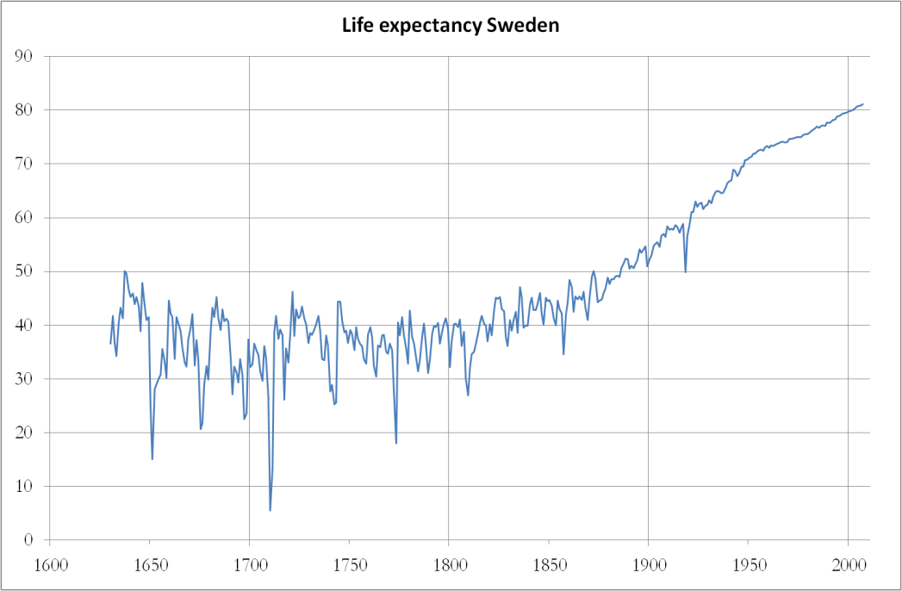
Famines and epidemics have become much rarer and much less severe in the 20th century. This is partly due to improved income and health in many of the countries of the world. However, famines and epidemics seem to have become rarer and less severe even in low-income countries, where health still is relatively poor during normal years. The reason is that skills and capacity to avert disaster have improved.
That being said, some of the worst mass deaths we know of, at least in terms of the number of people dead, have occurred during the 20th century. However, the big famines that have occurred during this period have occurred under more particular circumstances, generally related to authoritarian governments and war.
The Indian Nobel Laureate Amartya Sen has famously argued that lack of democracy is a prerequisite for famine, at least after 1900. The governments of today, even the poorer ones, generally have the tools to avert famine, if resolute actions are taken. That being said, the link between low income and famine is still evident.
However, that argument concerns famines, defined as a temporary extreme peak in excess mortality due to hunger. Stopping the more “modest” (relatively speaking) and ongoing problem of undernutrition is a very different problem. The degree of undernutrition is heavily influenced by average income levels and income distribution in the country.
The media often report that X number of people die from starvation every year. Sometimes students ask whether there really are so many people that starve to death. The answer is no. It is actually relatively rare that people starve to death, even during a famine. A human can survive for many months without food, and survive if they eventually get sufficient food.
“Dying from starvation” generally refers to the indirect effects of hunger. First, an undernourished person has a weaker immune system and can hence catch a number of diseases more easily. The risk of dying from some of those diseases is also higher.
Secondly, hunger has a number of effects on society at large. Refugee camps, poor housing or prisons can get crowded, and these places sometimes have poor sanitation. People move around more, in search for work. These and other conditions mean that a number of diseases spread more easily, which causes mortality to increase.
Many disasters are not visible in our data, or are inadequately represented. This is often due to the fact that there is no data for the specific years. The observations are instead based on what is known as interpolation, which is just a fancy name for drawing a straight line between two points. This is a major pedagogical drawback, since it might leave the student under the impression that temporary disasters were less widespread than they actually were. We hope to improve the coverage of disasters in the future.

Some specific disasters
B
elow is a list of some of the major disasters since 1800. The list obviously includes only a small fraction of all the disasters.
1840s in Ireland: The great potato famine is one of the worst famines on record, in terms of percentage of population dead.
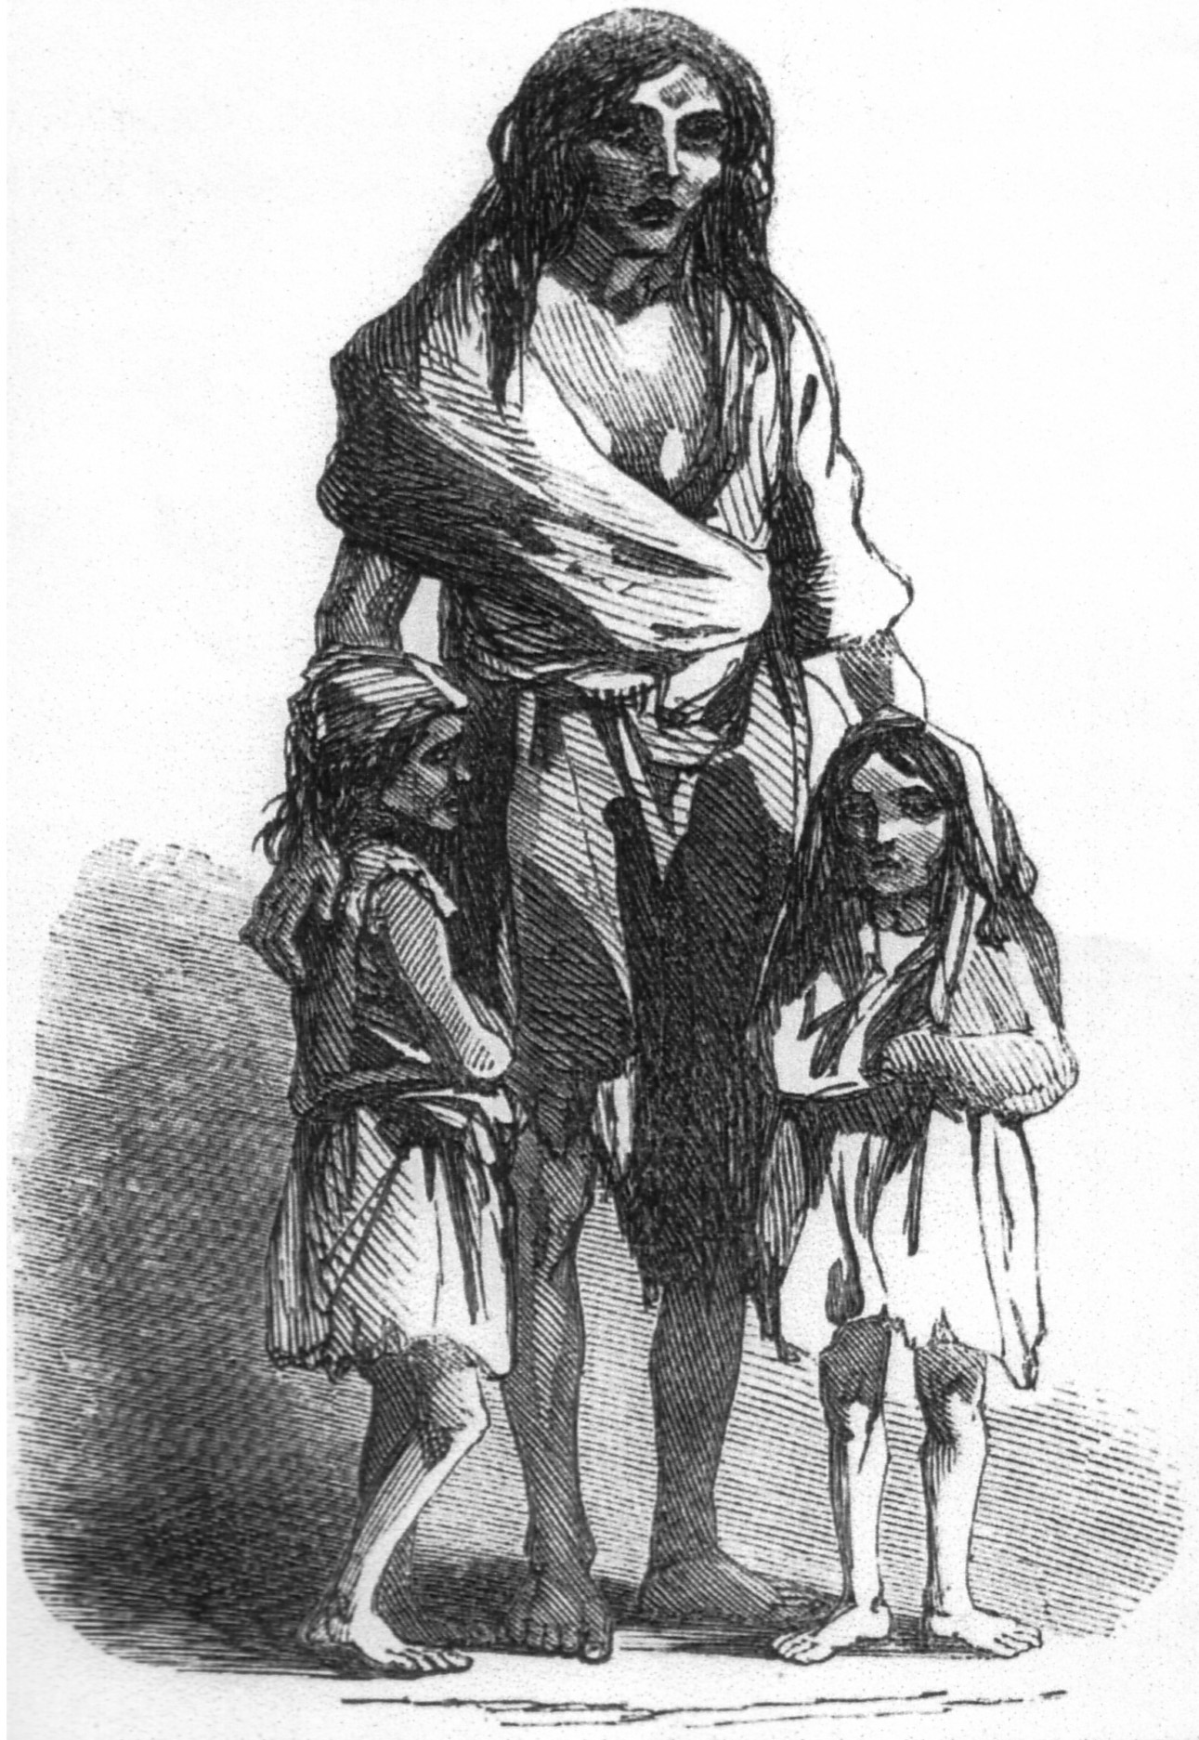
A starving mother and her two children during the Irish potato famine

1914-18: World War I affected a large part of the world.
1918-19: The “Spanish flu” was an influenza that spread across the world in the aftermath of the war. This was the last epidemic to significantly affect mortality in the industrial countries. The name comes from the fact that the first news reports were from Spain.
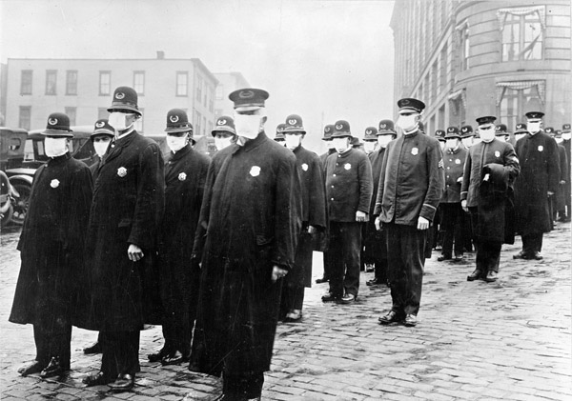
The Spanish Flu in Seattle, 1918. Policemen wearing masks.

1930s: The depression is one of the most well known economic recessions in history. It is seen in the graph as a small temporary drop in income for several countries (e.g. the US). However, in a long-term perspective this drop was small. What caused the most suffering was rather the high unemployment and the social problems linked to this.
1932: The Soviet Union was struck by a devastating famine in 1932-33. The famine mortality was high in a large area, stretching from Ukraine, Northern Caucasus to Kazakhstan. The geographical distribution of the famine is, at the time of writing, not totally accurately reflected in our data. We hope to correct that in the future.
1939-45: World War II affected a large part of the world.
1959-62 in China: In 1958 Mao launched a major economic reform campaign called “the great leap forward”. It was followed by a devastating famine, in which some 15 million are estimated to have died. This is probably the worst famine in world history, in terms of the number of people that died.
1975-79 Cambodia: The policies of the Khmer Rouge led to mass deaths of Cambodians on a horrific scale, both through famine and through executions.
1994 Rwanda: Somewhere between half a million and one million were killed in a few months in the Rwandan genocide.
1997 The Asian economic crisis: A financial crisis hit several East Asian countries in 1997. It is seen as a temporary income drop in, for example, Indonesia, Malaysia and South Korea.

About the 19th century
T
he data for GDP per capita before 1900 is, as already pointed out, very rough. Some facts are pretty clear, though. The United Kingdom was the richest country in the world in 1800. The industrial revolution started here in the late 18th century.

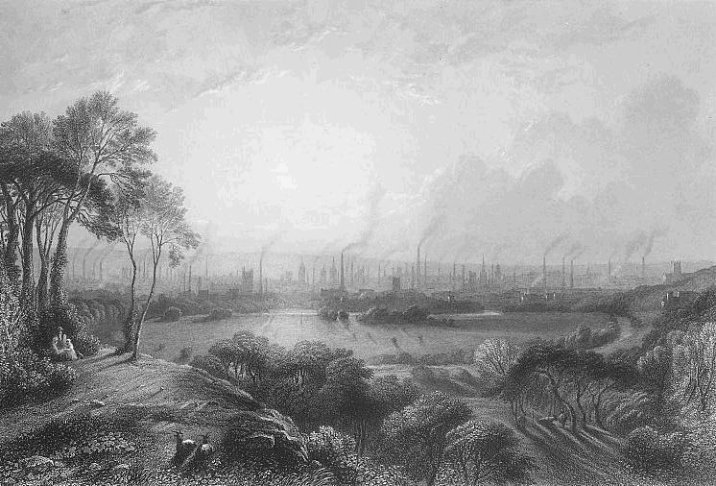

A painting of the industries of Manchester in the 19th century

The Netherlands was the second richest country in the world in 1800. They used to be the dominant economic power in the preceding centuries, which is normally referred to as the “Dutch golden age”.
Over the course of the 19th century, industrialisation spread from the United Kingdom across the world. It mainly spread to the rest of “the West”, but it also spread to other countries, such as parts of Latin America e.g. Argentina. Several governments outside “the West” also attempted to industrialise, for example Egypt (which failed), China (which largely failed) and Japan (which succeeded). When industrialisation started it was eventually followed by rising average incomes.
Health in 1800 was poor everywhere. Even the richest country, the United Kingdom, had a lower life expectancy, more or less, than even the poorest countries today. The reason for this poor health was partly the low income levels: every country was a low-income country at this time. However, the skills and capacity to prevent and deal with diseases and other public health problems were also poorer. Hence, your chances of survival were poorer than today, even if you had money.
The industrialisation of the West was a mixed blessing when it came to health. On one hand, it meant that large groups of society saw their incomes rise. This was positive for the health of these groups. The increased prosperity for society at large must also be considered positive for health, since it enabled society, in due time, to improve public services of importance for public health.
On the other hand, industrialisation generally meant increased urbanisation and crowding. Cities at this time generally had higher mortality rates than rural areas, since they were crowded and had poor sanitation. (In the low-income countries of today the pattern is typically the opposite: rural areas have higher mortality rates than the cities. This is because the cities of today have more to offer in terms of health care and public health measures.) Industrialisation was often also accompanied by major social shifts, and the systems for social protection were not always able to adjust properly, which meant that parts of the population were vulnerable in times of hardship.
The gaps between countries were smaller in 1800, both in terms of income per person and in terms of life expectancy. All countries were more or less poor, and all countries had more or less poor health. However, the income gaps within countries were substantial, as today.
Since 1800, global inequality has grown substantially, since some countries have forged ahead economically, while others have remained stagnant. It is inequality between countries that has grown. Inequality within countries has not changed as much.
If you, back in 1800, wanted to guess the economic level of a person you would ask: “Are you an aristocrat, a peasant, or a beggar?” In 2007 it would be better to ask “what is your home country?”. Of course, this does not mean that everyone from a specific country today has the same incomes. On the contrary, the gaps within countries are still substantial. It is just that today the economic differences between countries are so much larger than the economic differences within countries.
It is possible that global inequality has started to fall again slightly in the last couple of decades. The reason for that is that Asia is catching up. However, this depends on how you calculate inequality and the data is not good enough for any certain conclusions.

About the 20th century
O
il became an increasingly important source of energy in the first half of the century. Many prospective oil exporters, such as Qatar and Brunei, discovered oil even before the World War II. After the War oil became even more important and several oil exporters, many of which were Arab countries, became rich extremely fast.
Oil prices increased sharply in 1974 and 1979, known as the 1st and 2nd oil crises. The oil exporters gained additional income. However, the oil prices fell back again in the 1980s and most oil exporters experienced falling income. Nevertheless, they are still very rich. Note that the data is uncertain for many oil exporters.
In 1950 the majority of the poor in the world lived in Asia. However, there were some prosperous Asian nations, most notably Japan and Singapore.
Many experts at this time believed that poverty in Asia was bound to continue or even get worse. Some of the perceived problems were cultural constraints to industrialisation (e.g. the collectivistic mentality), overpopulation and large families.
Health started to improve in more and more countries. By 1950 this had turned into a global trend, and health started to get better even in the poorest countries. That was partly due to economic development in some of these countries. However, medical advancements also played a major role. A number of health measures were starting to be implemented by this time, e.g. the use of antibiotics.
A major setback to this global trend has been the HIV and AIDS epidemic that started in the 1980s. The southern tip of Sub-Saharan Africa has been hardest hit by the HIV and AIDS epidemic.
The countries that were already industrialised by 1950s, (e.g. “the West”, Japan and a few others), continued to grow richer and healthier. They become high income countries by the 1960s. Their economies increasingly moved away from industry and became more focused on other things, such as services.
A new trend after World War II was that industrialisation moved to new countries outside “the West”. The “Asian Tigers” (South Korea, Taiwan, Singapore and Hong Kong) are the most well known examples of this.
However, a few countries that used to be among the richest lost ground. South Africa lost ground from the 1970s and on. Argentina had started to lose ground by the depression in the 1930s, and their situation grew worse during the debt crises in the 1980s.
China, the biggest Asian country, came under communist rule in 1949 after decades of political turmoil and war. Income rose somewhat up to the 1970s and health improved significantly.
However, a massive famine struck the country during what was known as the “great leap forward” campaign 1958-61. Economic reforms were initiated in the late 1970s, which were followed by very fast economic growth.

About industry and economic growth
M
ost people in low-income countries are normally engaged in agriculture or related activities. When income levels increase in a country, this is typically accompanied by industrialisation. This means that more and more people move from agriculture to take up work in industry instead.
When income grows even higher, and the country becomes a high-income country, the service sector typically starts to grow more and more, and both industry and agriculture shrink.
There are exceptions, of course. For example, some countries have become rich through oil export or through the export of other raw materials.
However, the pattern where agriculture, industry and services take turns in being the main sector is quite universal. This is not strange. If we can afford only one thing, we choose food, which we need to survive. After food comes other basic needs, such as clothing. Incidentally, textiles is a typical key sector in the early phases of industrialisation.
This also explains why an agricultural revolution preceded the industrial revolution in most cases. Through innovation and reform the production of foodstuffs became more efficient. Once the population at large had their basic need for food fulfilled they could turn to demand more clothing and other industrial goods.

Practical details about this document
The front page photo was taken from “Okinawa Soba” on Flickr, published under a creative commons license. www.flickr.com/photos/24443965@N08/2855367940/sizes/o/in/set-72157606116199285/
The pictures on page 2 and 3 are from Gapminder. The pictures on page 23, 24 and 25 are all from Wikimedia Commons. They were taken from:
Page 23 (the Irish famine): http://en.wikipedia.org/wiki/File:Irish_potato_famine_Bridget_O'Donnel.jpg
Page 24 (the Spanish flu in Seattle): http://en.wikipedia.org/wiki/File:165-WW-269B-25-police-l.jpg
Page 25 (the industries of Manchester): http://upload.wikimedia.org/wikipedia/commons/e/e1/Cottonopolis1.jpg
The idea for the question “Are you an aristocrat...” on page 10 and 26 is based on a presentation by Branko Milanovic.
We have done our best to ensure the information in this document is as accurate as possible. Of course, there is always the risk that there are remaining errors and omissions. We are grateful for any comments, corrections and criticism, which can be e-mailed to:
Mattias.lindgren (at) gapminder.org

The discussion around poverty lines can be confusing since other income levels are sometime used to define absolute poverty. Sometimes $2 is used instead of $1.25 as the income line that defines poverty. People living on less than $1.25 obviously live in more extreme poverty than those that earn just a little less than $2. $1.25 is accordingly sometimes referred to as the “extreme (absolute) poverty line”. An even lower definition of absolute poverty has also been used, $1$ per day, but that definition is not used today. Note that all these definitions refer to absolute poverty.

